First Make repository on Android Studio

1 step

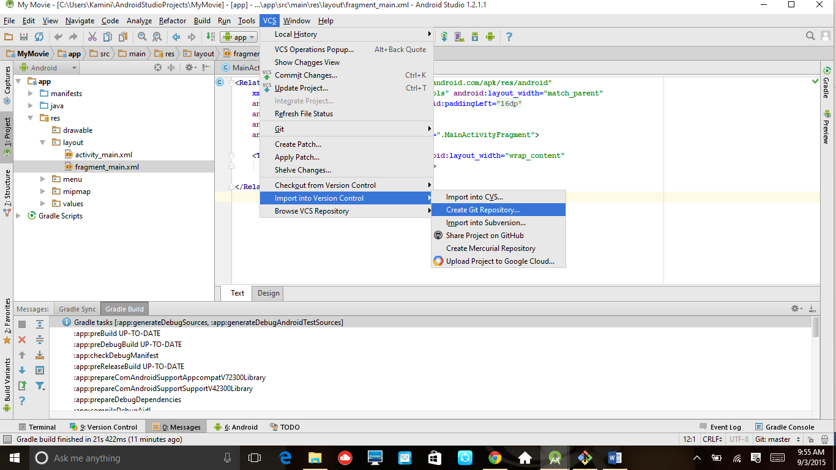

2 step : create repository in your project like MyMovie then clieck on ok Button

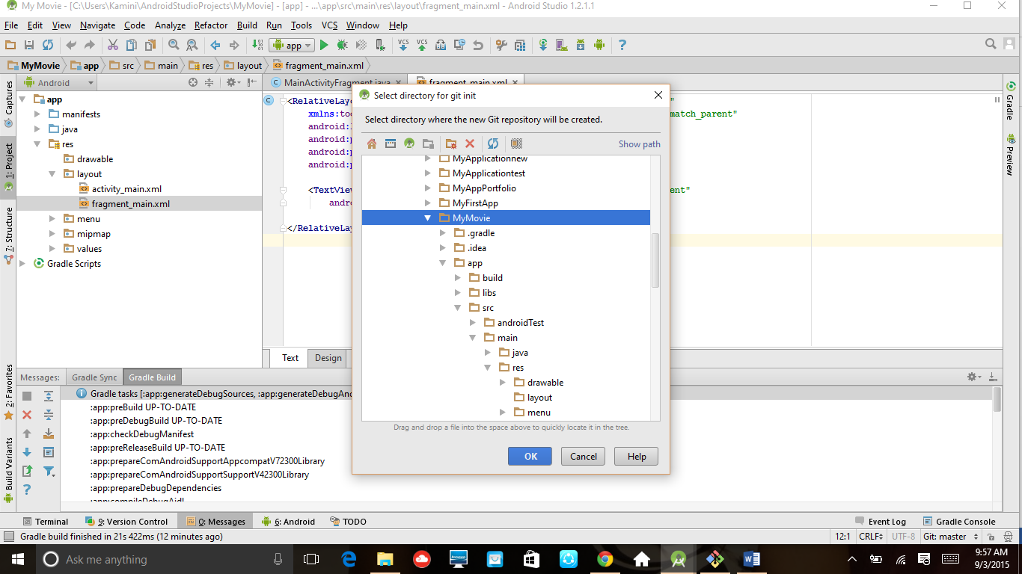

3 Step

Open git bash check with ls –a command

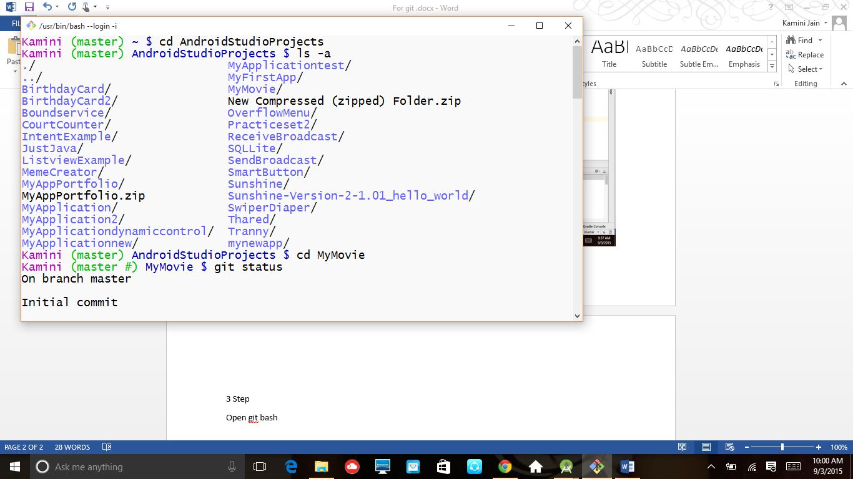

4 step go on ur directory us cd directory name like cd mymovie then give command git status

This command give the status of files which is not included

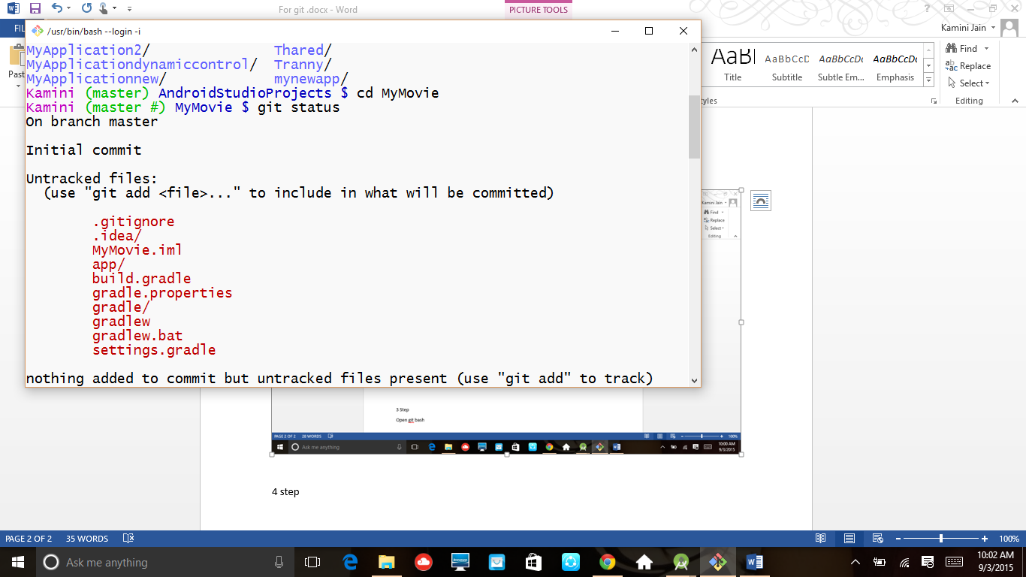

5 step type git add . for add all files in repositary

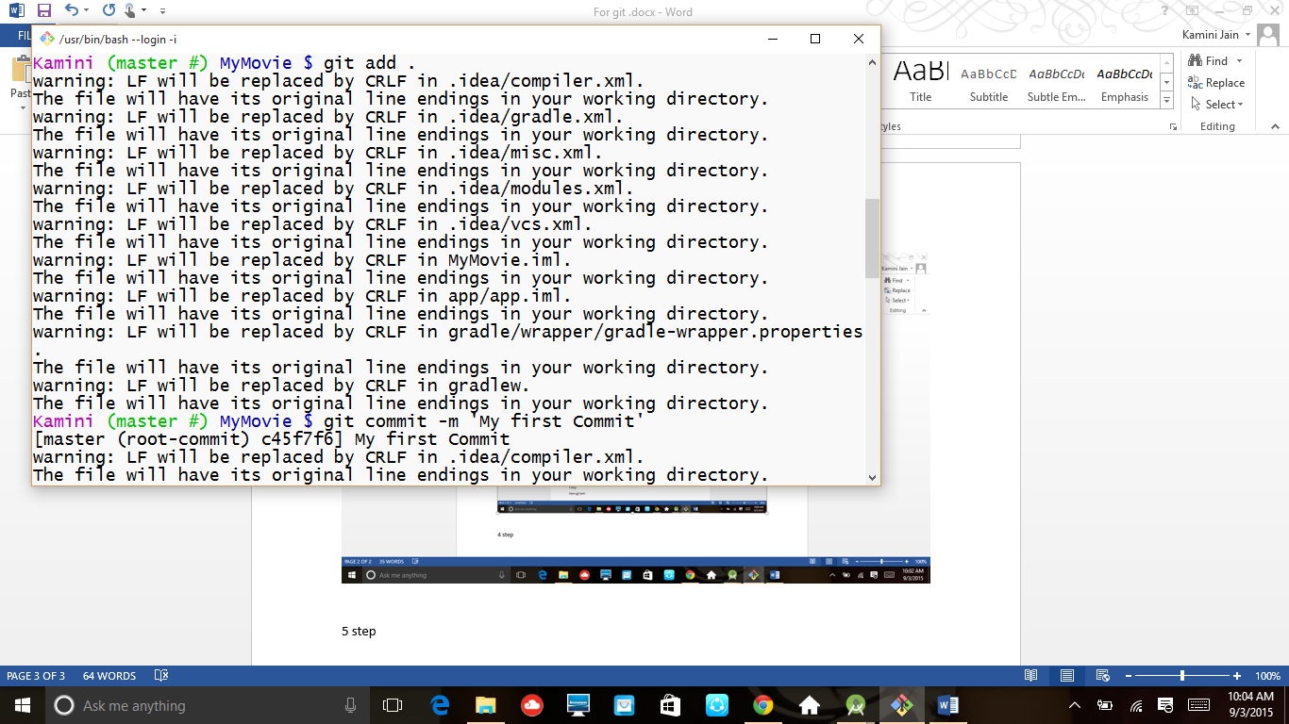

6 step git commit –m ‘any message’ for commit any files

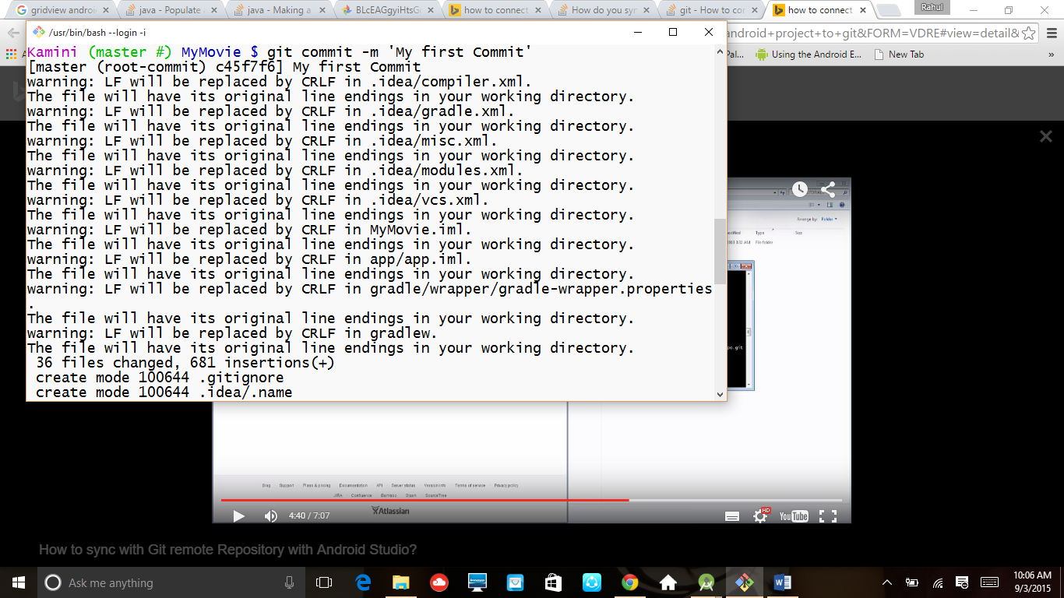

7 step git status to check the status of files

